Media credits list http://research.ncl.ac.uk/romtels/resources/tech/
Enquiry 1 – Great Fire of Tyneside

SECTION | DESCRIPTION | THUMBNAIL | CREDITS
Start | Firestation – exterior | 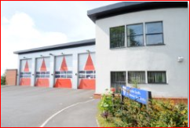 | WM Karen Soady  Prevention & Education Department  Newcastle District  Tyne and Wear Fire & Rescue Service  Tel: 0191 4441001  Mobile: 07909955673  <Karen.Soady@twfire.gov.uk>
 | Firestation – interior | 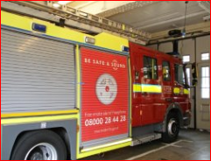 | https://www.flickr.com/photos/pikerslanefarm/9655568768/in/photolist-fHejcA-7QryXB-8BGjHM-ovf6Pg-ovfMEg-ovfUeP-q6nMfk-da1Dqc-4vvMx1-fGWJnV-fHehML-fGWGZT-da1DJb-q58Lkq-pMzhZv-ooY6W7-iMj51N-p8V1GN-j89xJc-j8cu3w-dehpSf-4tBruF-da1DdK-pq8aAH-99coGW-99cpf5-99ctUW-999min-999kXi-999kgt-99cvxu-999iq2-99csJs-99cs2E-99cqfm-99cuhd-999hyT-99cv6u-99cuBo-999g1H-999jqV-99crbd-spfks-ponpLf-pqnPfo-p8UvLo-p8Ux9J-pqpiD8-pqpidt-cEC2So  CC license on Flickr https://www.flickr.com/photos/pikerslanefarm/
 |  | 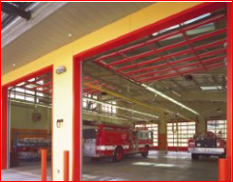 | https://www.flickr.com/photos/dondommerassociates/3347680696/in/photolist-66PJQG-66KuiT-5iqLmn-byd1YV-9ZcAe4-8X3MD5-5HwRp4-p8UtAm-6ajf4Q-fWmCVG-4tBrq8-6kYNsK-o5TLpK-jEXf1s-JJv38-MZAcj-6SGhKp-9J3VTr-dhmuRH-cCpLFb-cQVEcw-e24T5B-8mDoTm-pDqppg-pmVMhS-7z6Z5K-7atQmv-7atQuF-4ucTka-6rbwWN-pDqCup-pDoy5y-dpk3iv-pD9em8-pD9gug-aoNZWq-cQVKBd-4qH73H-9czEmr-3hZSpP-C8bpc-ijPWfP-4HGsBT-8P7atL-c81jtj-2VRKtL-55TKEv-2PCPDh-c81yFW-c81z4N  CC license on Flickr https://www.flickr.com/photos/dondommerassociates/
 | Gravestone | Lonely Tower video clip | Lonely Tower video clip
Section A | Olden days Gateshead fireman | 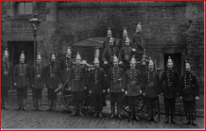 | http://www.gatesheadpolice.org/firebrigade.htm and email permission 21st May 2015
 | Olden days Gateshead fire engine | 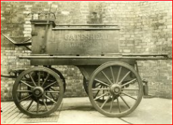
 | Ncl view pre-John Dobson | 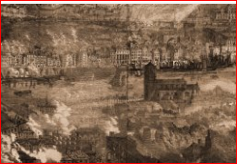 | out of copyright image on Flickr  https://www.flickr.com/photos/74726036@N04/
 | Ncl view post-John Dobson | 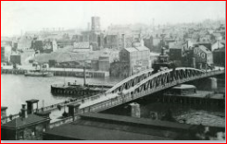 | out of copyright image on Flickr  https://www.flickr.com/photos/74726036@N04/
 |  | 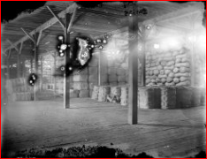 | https://www.flickr.com/photos/boston_public_library/5404152091/in/photolist-eaPwwj-eaPwU5-eaPx1U-eaPwoo-eNBWpb-54Vzc-eNBEYG-3i3JTA-wSrH9-eNBSWb-eNqsdp-eNqrvZ-nfq47n-bfZCCZ-bGE8ic-bGE8m4-p456dT-2Zw6VL-p7iTsT-pouLyP-eNqq4T-fbJpjf-h5AT1T-k64PRX-e6qyrE-kCUXVj-itpcV5-iuJZrb-bvh8gT-ugHr8-6H82H-fDWe12-kdSUSz-ecQwWA-bgMWSa-dJbXg2-9exG94-n6UBN-4c9Swn-4aFM8a-bkwmiP-aNdpxc-ekDeZx-bvHLya-bvHMp4-5VBGF4-fbJuzA-7U7pSG-5VBGCa-8qfm1G  CC license on Flickr
 | Fireballs video |  | http://www.videezy.com/fire-and-smoke/2329-rising-fire-sparks-hd-stock-video  copyright free video clip
Section E | Resident on Quayside; shops | 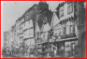  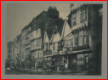  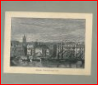 | pre-fire quayside  Newcastle Library permission email from Sarah Mulligan
 |  | 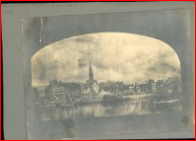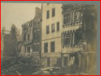  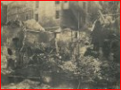  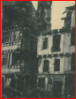  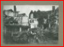 | post-fire quayside  Newcastle Library permission email from Sarah Mulligan
Section F | Tourist on bridge | 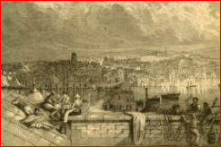 | out of copyright image in Flickr  https://www.flickr.com/photos/74726036@N04/
 |  | 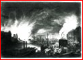  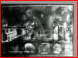  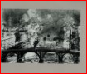 | Newcastle Library permission email from Sarah Mulligan
More Quayside | Bessie Surtees House | 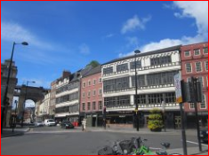 | http://www.geograph.org.uk/more.php?id=3067375 CC BY-SA 2.0 Graham Robson
post-fire
Newcastle Library permission email from Sarah Mulligan
 | old wall | 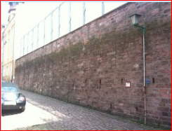 | https://www.flickr.com/photos/51061855@N05/4693010363/in/photolist-89GUtM-8pXMcM-91vYJ9-aG1aAZ-bEEkqK-8mjoDf-dCKhxp-sgSvrZ-dwzszd-dwzsg3-8qp2nm-auD25s-vYBgqR-q2FtZ1-aBgpqB-8WFRRo-84anxC-b5qVhn-dRLygF-dAezaH-qhqoxv-djzGZE-8qp2tG-woDHw-rXApCv-5z8pmG-85RrkT-qgzKPq-e43dyq-uGEEs4-5oUAn6-xkWcV6-6aXmrT-4Z5PYc-91vR6G-oeJ4BF-dC2Ff-hmXtJL-dBueDw-cztmNS-a7vkB7-a439eF-wnCN4p-ect4YB-fAUNhS-n2DYZi-axJpTf-dW6o1D-qaB6hb-fmh1ki Flicker oliver.hoerold CC BY-SA 2.0
 | slums | 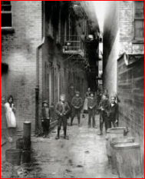 | https://commons.wikimedia.org/wiki/File:Mullen%27s_Alley,_New_York,_by_Jacob_Riis.jpg by Jacob Riis, now in public domain
 | slums | 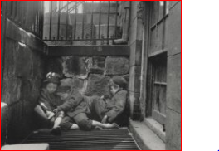 | https://commons.wikimedia.org/wiki/File:Sleeping,_homeless_children_-_Jacob_Riis.jpg by Jacob Riis, now in public domain
 | tightly packed housing | 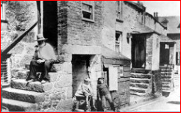 | https://commons.wikimedia.org/wiki/Category:Victorian_era#/media/File:Victorian_Bishopgate.jpg by C Lodge, now in public domain

